From: Association of BellTel Retirees Inc.

Butler Associates, Public Relations
Media Contact: 212-685-4600
Tom Butler - 646-213-1802 TButler@Butlerassociates.com
Victoria Carman - 646-205-7627 VCarman@Butlerassociates.com
Jason Fink - 646-213-1369 JFink@Butlerassociates.com

Verizon retiree association celebrates 20 years of fighting for earned benefits

Association of BellTel Retirees gathered in Tarrytown to discuss the ongoing fight against executive golden parachutes, pension spin-offs

One of the nation’s largest retiree organizations celebrated its 20th anniversary in Tarrytown, to discuss its efforts to limit excessive executive golden parachutes, protect earned benefits and fight for 134,000 members who are retired from Verizon or its predecessor companies.

The retirees, who met on April 19 at The DoubleTree Hotel in Tarrytown, welcomed special guest State Senator Andrea Stewart-Cousins, who represents a large segment of Westchester County and serves as minority leader in the legislature’s upper chamber. She presented the group with a legislative proclamation honoring its 20 years of advocacy.

The meeting included discussions about ongoing efforts to protect retiree pensions and benefits as well as legislative activities the group has in place across the United States. The Association is also supporting the CWA and IBEW union workers now on strike and has instructed its members not to fill in for striking workers, if asked.

The Association’s attorneys Curtis Kennedy and Edward Stone each addressed retirees’ questions about their pensions, ongoing federal litigation and legislation to add protection for retirees whose pension have been “de-risked” or converted to insurance annuities. The Association currently has litigation challenging Verizon’s decision to sell off the pensions of 41,000 retirees to Prudential Insurance and the U.S. Supreme Court is currently considering whether to hear the case.

Representatives from Prudential, who also presented an award to BellTel, were also in attendance to answer the questions and concerns about those pension-annuities.

“We would like to thank everyone for making our 20th anniversary celebration special,” said BellTel President John Brennan. “We are humbled by the honors we were awarded by Senator Stewart-Cousins and Prudential and we will continue fighting against the threat to long term benefits for retirees and their families.”

Mr. Brennan also read a letter from Richard Speer, President/Business Manager of the IBEW Local 827, representing striking Verizon workers, thanking the Association for its support.

Each year, since its founding, the Association has chosen different locations across the U.S. to host its membership meetings, to give its members across the U.S. a chance to meet with and share their concerns about their retirement and the security of their healthcare. Many thousands have participated in BellTel events.

The Association of BellTel Retirees, the 134,000 member non-profit advocacy group works for the protection of Verizon retirees’ pensions and benefits. Verizon is the largest telecommunications firm in the world and its more than a quarter million retirees hail from the old Bell System including NYNEX, New York Telephone, New Jersey Bell and Bell Atlantic, Bell of Pennsylvania, MCI and GTE. More information about the Association can be found at www.BellTelRetirees.Org

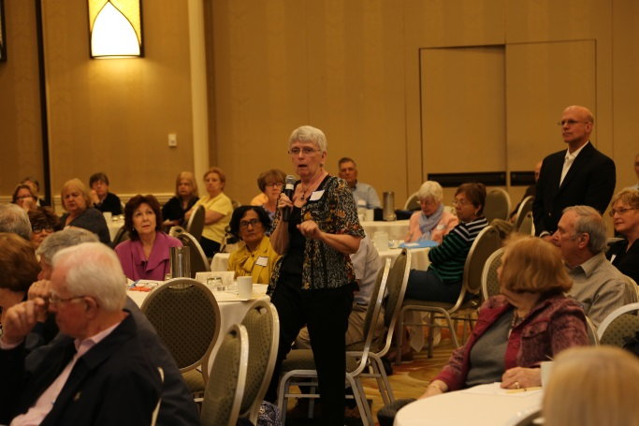

Photo 1: BellTel Members asks the retiree leaders questions during Q&A of the meeting

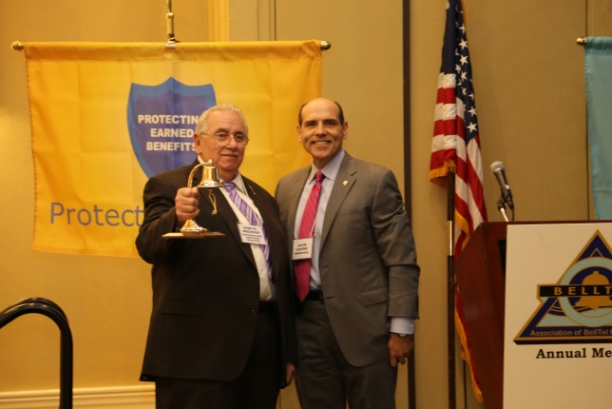

Photo 2: Prudential Representative David Castro presents BellTel President John Brennan with an award for the group’s advocacy on behalf of Verizon retirees.

\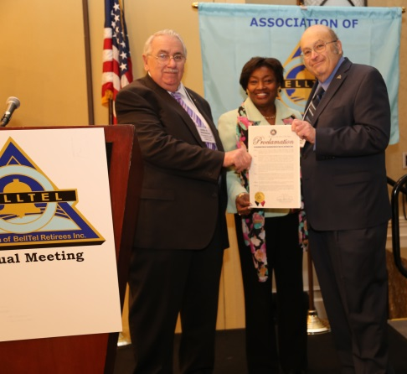
Photo 3: New York State Senator Andrea Stewart-Cousins presents the Association with a proclamation awarding them for their advocacy.

Photo credit: David Simmonds, Director of the Association of BellTel Retirees

